Images

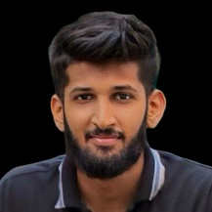 anjana.jpg

camera_6.jpg

Output Screenshots

Figure 1 Verification

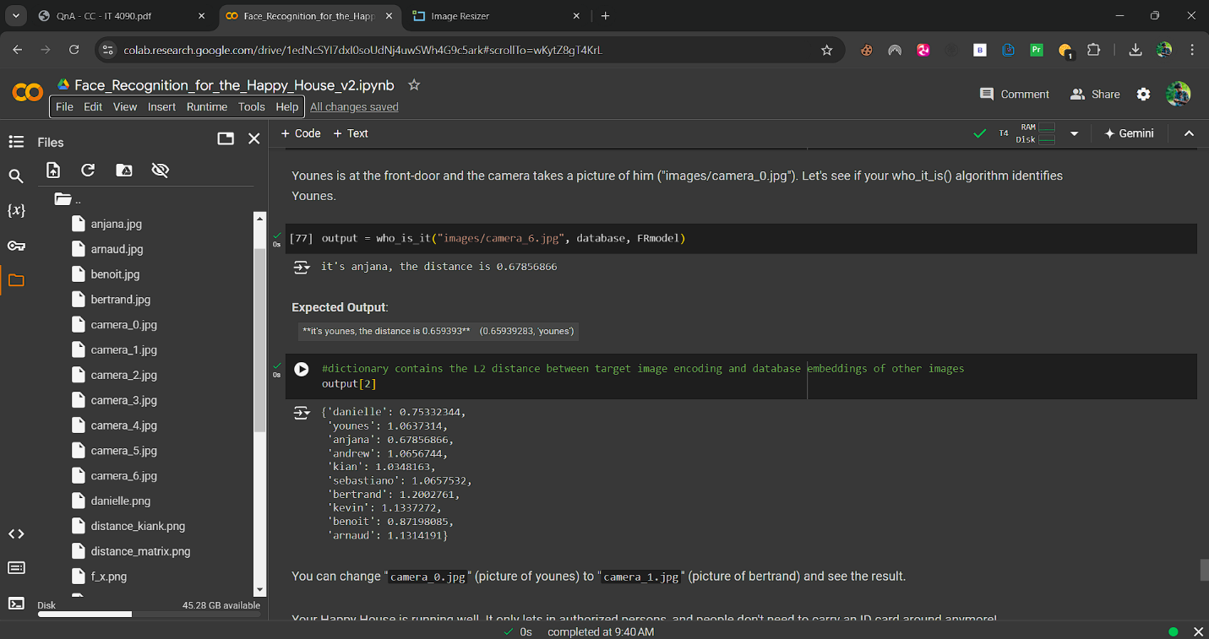

Figure 2 Recognition and output[2]